Name: ________________________

Road Trip
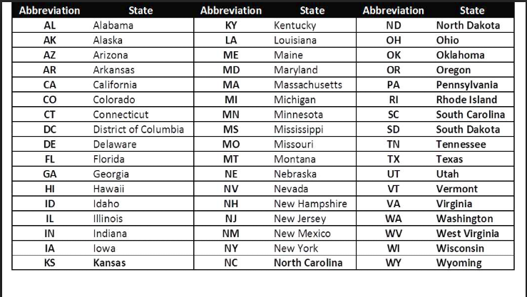

You are planning a road trip starting in New York, use (20, 20) as the coordinates of NY. The road trip must last 7 days and you must travel to 7 different States within that time.
Step 1: Research cars and pick a car that you are going to use on your road trip. Fill in the following information about the car that you chose. Print out a picture of your car.

Car Brand: ___________ Make/Model: _____________

Miles per gallon (city): _____________

Step 2: Map out the 7 States that you would like to travel to. Include the coordinates of the States in your travel plan. Using the coordinates you found, find the distance between the two states using the distance formula. Be sure that you will be able to travel to all 7 States within 7 days.

Travel Plan | Distance | Convert boxes to miles
NY (20, 20) to _____________

_____________ to _____________
_____________ to _____________

_____________ to _____________

_____________ to _____________

_____________ to _____________

_____________ to _____________

Step 3: Research the current cost of regular gas. How much would you spend on gas for your trip?

Step 4: You have to plan something special to do for each day of your trip. For example, if you were to visit Orlando, Florida you may want to visit Walt Disney World for the day. If you plan to visit Arizona, you may want to go see the Grand Canyon. On 7 separate sheets of paper, include a photo of where you would like to visit within the State. Be sure to include the State that this is located and the name of the location (for example, Florida: Walt Disney World).

Step 5: Create a poster to illustrate your road trip and all of the States and places you would like to visit.

Sample Poster Layout

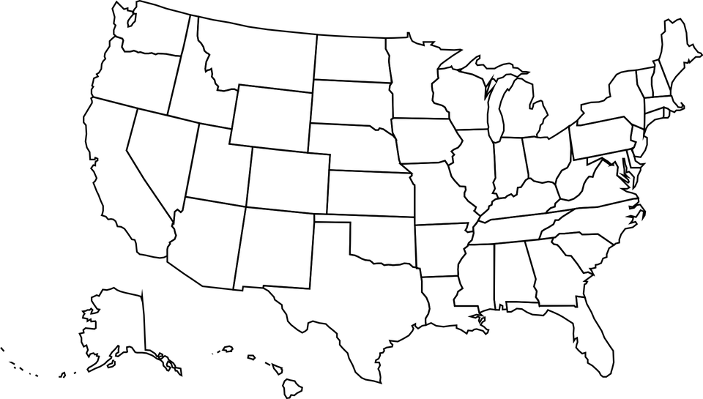
Sara’s Road Trip

